**Experiment 5.1**

**Student Name:** Sahil Kaundal **UID:** 21BCS8197

**Branch:** CSE (Lateral Entry)  **Section/Group:** 616/A

**Semester:** 6th **Date of Performance:** 30/03/2023

**Subject Name:** Mobile Application Development Lab **Subject Code:** 20CSP-356

1. **Aim:**

Create an Android App using various controls such TexEdit, CheckBox, RadioButton, RadioGroup, etc.

**Creating** the Application Choosing Options Checkbox.

1. **Objective:**

**Creating** the Application Choosing Options Checkbox.

CheckBox belongs to android.widget.CheckBox class. Android CheckBox class is the subclass of CompoundButton class. It is generally used in a place where user can select one or more than choices from a given list of choices.

*public class* CheckBox *extends* CompoundButton

1. **System Requirements:**

* Microsoft Windows 7/8/10 (32-bit or 64-bit)
* 4 GB RAM minimum, 8 GB RAM recommended (plus 1 GB for the Android Emulator)
* 2 GB of available disk space minimum, 4 GB recommended (500 MB for IDE plus 1.5 GB for Android SDK and emulator system image)
* 1280 x 800 minimum screen resolution
* Java JDK5 or later version
* Java Runtime Environment (JRE) 6 Android Studio

1. **Steps/Program:**

**activity_main.xml**

<?xml version="1.0" encoding="utf-8"?>

<androidx.constraintlayout.widget.ConstraintLayout xmlns:android="http://schemas.android.com/apk/res/android"

xmlns:app="http://schemas.android.com/apk/res-auto"

xmlns:tools="http://schemas.android.com/tools"

android:layout_width="match_parent"

android:layout_height="match_parent"

android:textAlignment="center"

tools:context=".MainActivity">

<TextView

android:id="@+id/textView"

android:layout_width="match_parent"

android:layout_height="50sp"

android:layout_marginBottom="40dp"

android:gravity="center"

android:text="Select Your Choice"

android:textSize="20sp"

android:textStyle="bold|italic"

app:layout_constraintBottom_toTopOf="@+id/ch1"

app:layout_constraintEnd_toEndOf="parent"

app:layout_constraintHorizontal_bias="0.498"

app:layout_constraintStart_toStartOf="parent" />

<Button

android:id="@+id/submit"

android:layout_width="wrap_content"

android:layout_height="wrap_content"

android:layout_marginTop="40sp"

android:backgroundTint="#E17243"

android:fontFamily="sans-serif-medium"

android:text="Submit"

android:textColor="#FDF322"

android:textColorHighlight="#973B3B"

android:textColorHint="#C34444"

android:textSize="16sp"

android:textStyle="bold|italic"

app:iconTint="#9F4040"

app:layout_constraintEnd_toEndOf="parent"

app:layout_constraintStart_toStartOf="parent"

app:layout_constraintTop_toBottomOf="@+id/ch4"

app:rippleColor="#D83838" />

<CheckBox

android:id="@+id/ch2"

android:layout_width="120sp"

android:layout_height="wrap_content"

android:layout_marginTop="24dp"

android:fontFamily="sans-serif-black"

android:gravity="center"

android:text="Books"

android:textSize="16sp"

app:layout_constraintEnd_toEndOf="parent"

app:layout_constraintStart_toStartOf="parent"

app:layout_constraintTop_toBottomOf="@+id/ch1" />

<CheckBox

android:id="@+id/ch1"

android:layout_width="120sp"

android:layout_height="wrap_content"

android:layout_marginTop="150sp"

android:fontFamily="sans-serif-black"

android:gravity="center"

android:text="Football"

android:textSize="16sp"

app:layout_constraintEnd_toEndOf="parent"

app:layout_constraintStart_toStartOf="parent"

app:layout_constraintTop_toTopOf="parent" />

<CheckBox

android:id="@+id/ch3"

android:layout_width="120sp"

android:layout_height="wrap_content"

android:layout_marginTop="24dp"

android:fontFamily="sans-serif-black"

android:gravity="center"

android:text="Cricket"

android:textSize="16sp"

app:layout_constraintEnd_toEndOf="parent"

app:layout_constraintStart_toStartOf="parent"

app:layout_constraintTop_toBottomOf="@+id/ch2" />

<CheckBox

android:id="@+id/ch4"

android:layout_width="120sp"

android:layout_height="wrap_content"

android:layout_marginTop="24dp"

android:fontFamily="sans-serif-black"

android:gravity="center"

android:text="Coding"

android:textSize="16sp"

app:layout_constraintEnd_toEndOf="parent"

app:layout_constraintStart_toStartOf="parent"

app:layout_constraintTop_toBottomOf="@+id/ch3" />

<TextView

android:id="@+id/txt"

android:layout_width="match_parent"

android:layout_height="wrap_content"

android:layout_marginBottom="100dp"

android:gravity="center"

android:textSize="24sp"

app:layout_constraintBottom_toBottomOf="parent"

app:layout_constraintEnd_toEndOf="parent"

app:layout_constraintStart_toStartOf="parent" />

</androidx.constraintlayout.widget.ConstraintLayout>

**MainActivity.java**

package com.example.checkbox;

import androidx.appcompat.app.AppCompatActivity;

import android.os.Bundle;

import android.view.View;

import android.widget.Button;

import android.widget.CheckBox;

import android.widget.TextView;

import java.util.ArrayList;

public class MainActivity extends AppCompatActivity {

private CheckBox ch1,ch2,ch3,ch4;

private Button submit;

private TextView txt;

@Override

protected void onCreate(Bundle savedInstanceState) {

super.onCreate(savedInstanceState);

setContentView(R.layout.activity_main);

ch1 = findViewById(R.id.ch1);

ch2 = findViewById(R.id.ch2);

ch3 = findViewById(R.id.ch3);

ch4 = findViewById(R.id.ch4);

submit = findViewById(R.id.submit);

txt = findViewById(R.id.txt);

submit.setOnClickListener(new View.OnClickListener() {

@Override

public void onClick(View view) {

String chkb1 = ch1.getText().toString();

String chkb2 = ch2.getText().toString();

String chkb3 = ch3.getText().toString();

String chkb4 = ch4.getText().toString();

if (ch1.isChecked() && ch2.isChecked() && ch3.isChecked() && ch4.isChecked()){

txt.setText("Selected : "+chkb1+""+chkb2+""+chkb3+""+chkb4);

}

else if (ch1.isChecked()) {

txt.setText("Selected : "+chkb1);

}

else if (ch2.isChecked()){

txt.setText("Selected : "+chkb2);

}

else if (ch3.isChecked()) {

txt.setText("Selected : "+chkb3);

}

else if (ch4.isChecked()) {

txt.setText("Selected : "+chkb4);

}

else {

txt.setText("Please Select Any CheckBox"); } }

});

}

}

1. **Result/Output:**

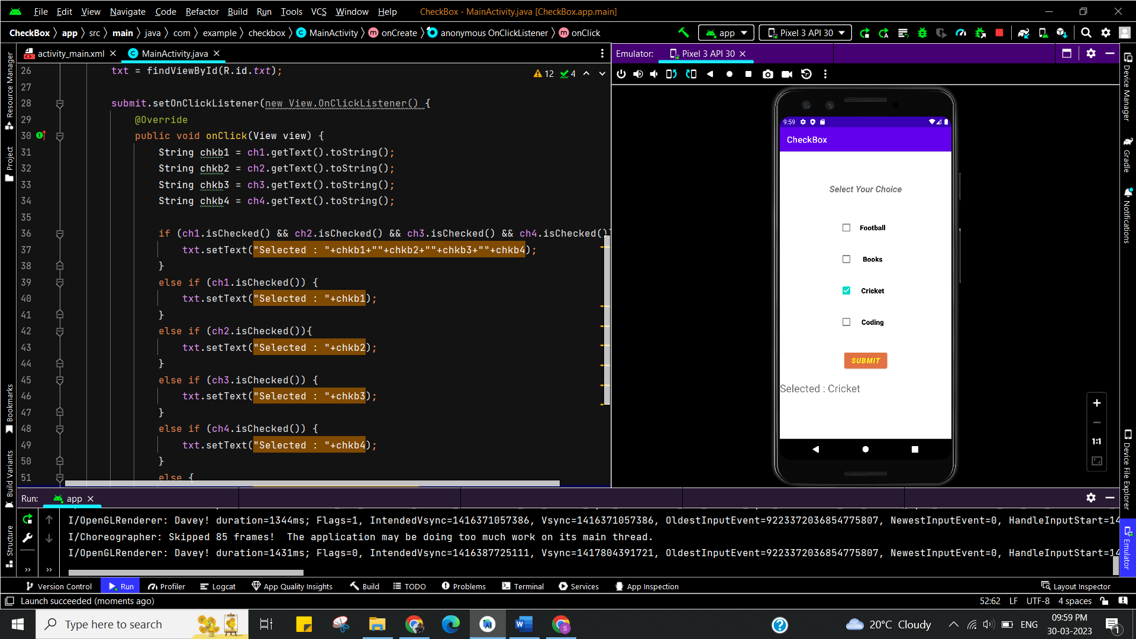

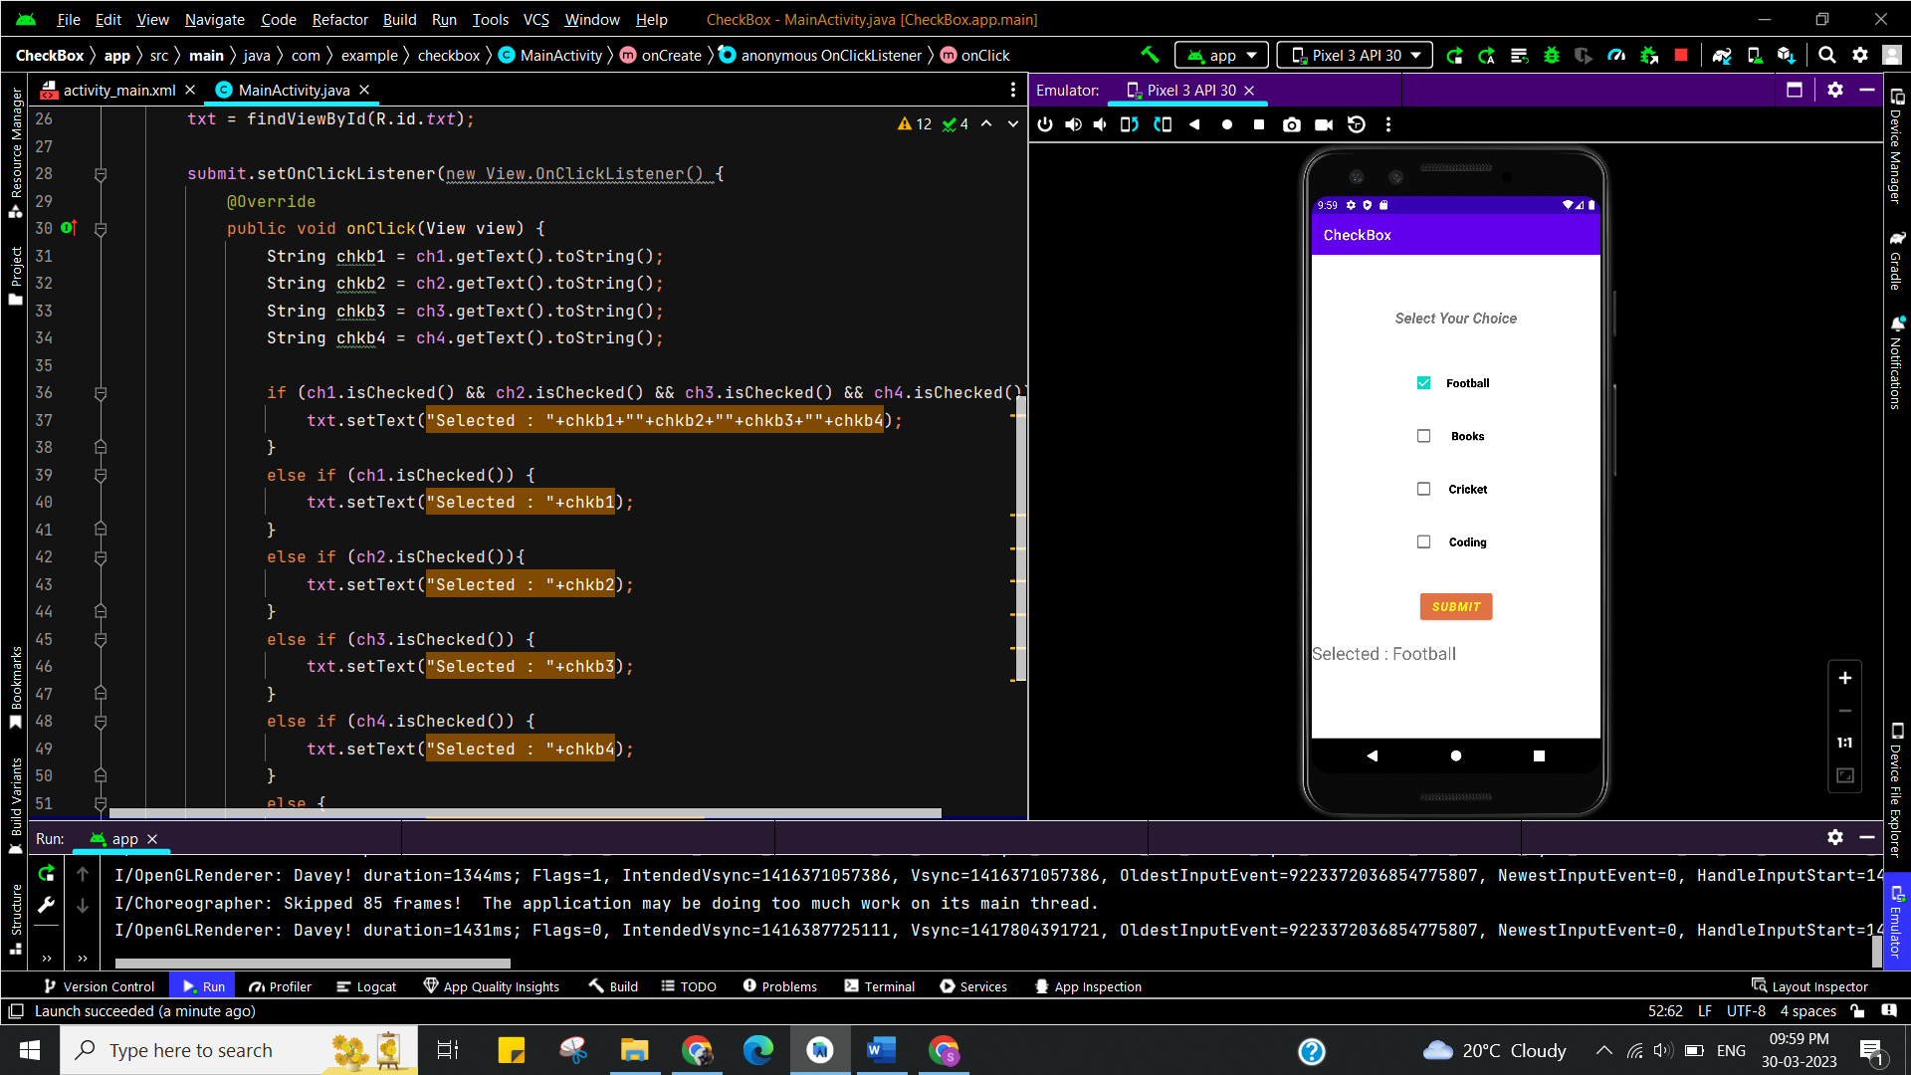

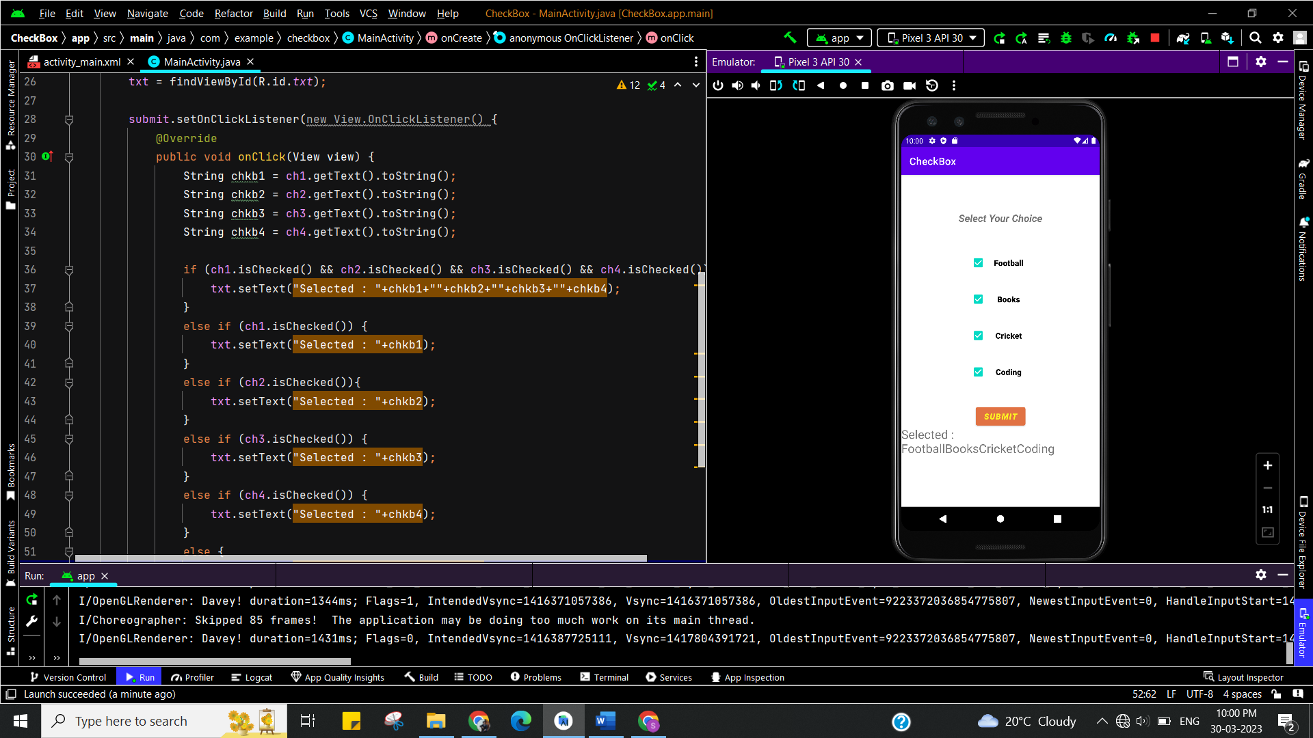

**Learning outcomes (What I have learnt):**

* To design an android application which uses checkboxes in android studio.
* Learnt about running application on android studio.

**Experiment 5.2**

1. **Aim:**

Create an Android App using various controls such TexEdit, CheckBox, RadioButton, RadioGroup, etc.

**Creating** the Application Choosing Options RadioButton.

1. **Objective:**

**Creating** the Application Choosing Options RadioButton.

**RadioButton** is a two states button which is either checked or unchecked. If a single radio button is unchecked, we can click it to make checked radio button. Once a radio button is checked, it cannot be marked as unchecked by user. RadioButton is generally used with RadioGroup. RadioGroup contains several radio buttons, marking one radio button as checked makes all other radio buttons as unchecked.

1. **System Requirements:**

* Microsoft Windows 7/8/10 (32-bit or 64-bit)
* 4 GB RAM minimum, 8 GB RAM recommended (plus 1 GB for the Android Emulator)
* 2 GB of available disk space minimum, 4 GB recommended (500 MB for IDE plus 1.5 GB for Android SDK and emulator system image)
* 1280 x 800 minimum screen resolution
* Java JDK5 or later version
* Java Runtime Environment (JRE) 6 Android Studio

1. **Steps/Program:**

**activity_main.xml**

**<?xml version="1.0" encoding="utf-8"?>**

**<androidx.constraintlayout.widget.ConstraintLayout xmlns:android="http://schemas.android.com/apk/res/android"**

**xmlns:app="http://schemas.android.com/apk/res-auto"**

**xmlns:tools="http://schemas.android.com/tools"**

**android:layout_width="match_parent"**

**android:layout_height="match_parent"**

**android:orientation="vertical"**

**android:padding="20sp"**

**tools:context=".MainActivity">**

**<RadioGroup**

**android:id="@+id/subject_group"**

**android:layout_width="wrap_content"**

**android:layout_height="wrap_content"**

**tools:layout_editor_absoluteX="20dp"**

**tools:layout_editor_absoluteY="20dp"**

**tools:ignore="MissingConstraints">**

**<TextView**

**android:id="@+id/textView2"**

**android:layout_width="match_parent"**

**android:layout_height="match_parent"**

**android:gravity="center"**

**android:text="Subject"**

**android:textSize="20sp" />**

**<RadioButton**

**android:id="@+id/radioButton10"**

**android:layout_width="match_parent"**

**android:layout_height="wrap_content"**

**android:text="DBMS" />**

**<RadioButton**

**android:id="@+id/radioButton11"**

**android:layout_width="match_parent"**

**android:layout_height="wrap_content"**

**android:text="Object Oriented" />**

**<RadioButton**

**android:id="@+id/radioButton12"**

**android:layout_width="match_parent"**

**android:layout_height="wrap_content"**

**android:text="C/ C++ Programming" />**

**<RadioButton**

**android:id="@+id/radioButton13"**

**android:layout_width="match_parent"**

**android:layout_height="wrap_content"**

**android:text="Algorithm" />**

**</RadioGroup>**

**<Button**

**android:id="@+id/btn"**

**android:layout_width="match_parent"**

**android:layout_height="wrap_content"**

**android:layout_marginTop="70dp"**

**android:text="Submit"**

**app:layout_constraintTop_toBottomOf="@+id/subject_group"**

**tools:layout_editor_absoluteX="20dp" />**

**</androidx.constraintlayout.widget.ConstraintLayout>**

**MainActivity.java**

package com.example.prac52radiobutton;

import androidx.appcompat.app.AppCompatActivity;

import android.os.Bundle;

import android.view.View;

import android.widget.Button;

import android.widget.RadioGroup;

import android.widget.Toast;

public class MainActivity extends AppCompatActivity implements RadioGroup.OnCheckedChangeListener {

RadioGroup radioGroup;

Button btn_result;

String Subject;

@Override

protected void onCreate(Bundle savedInstanceState) {

super.onCreate(savedInstanceState);

setContentView(R.layout.activity_main);

radioGroup = (RadioGroup) findViewById(R.id.subject_group);

btn_result = (Button) findViewById(R.id.btn);

radioGroup.setOnCheckedChangeListener(this);

btn_result.setOnClickListener(new View.OnClickListener() {

@Override

public void onClick(View view) {

Toast.makeText(MainActivity.this, Subject, Toast.LENGTH_SHORT).show();

}

});

}

@Override

public void onCheckedChanged(RadioGroup radioGroup, int i) {

switch (i){

case R.id.radioButton10:

Subject = "DBMS";

break;

case R.id.radioButton11:

Subject = "Object Oriented";

break;

case R.id.radioButton12:

Subject = "C/ C++ Programming";

break;

case R.id.radioButton13:

Subject = "Algorithm";

break;

}

}

}

1. **Result/Output:**

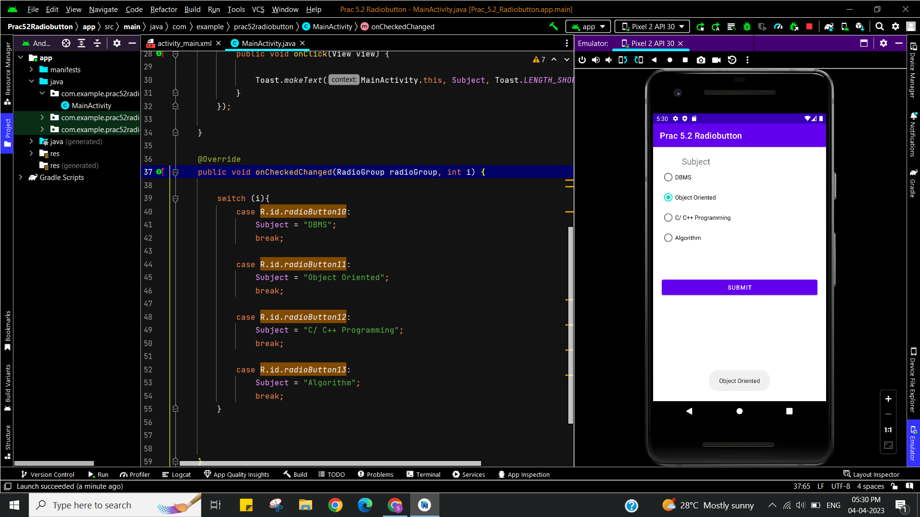

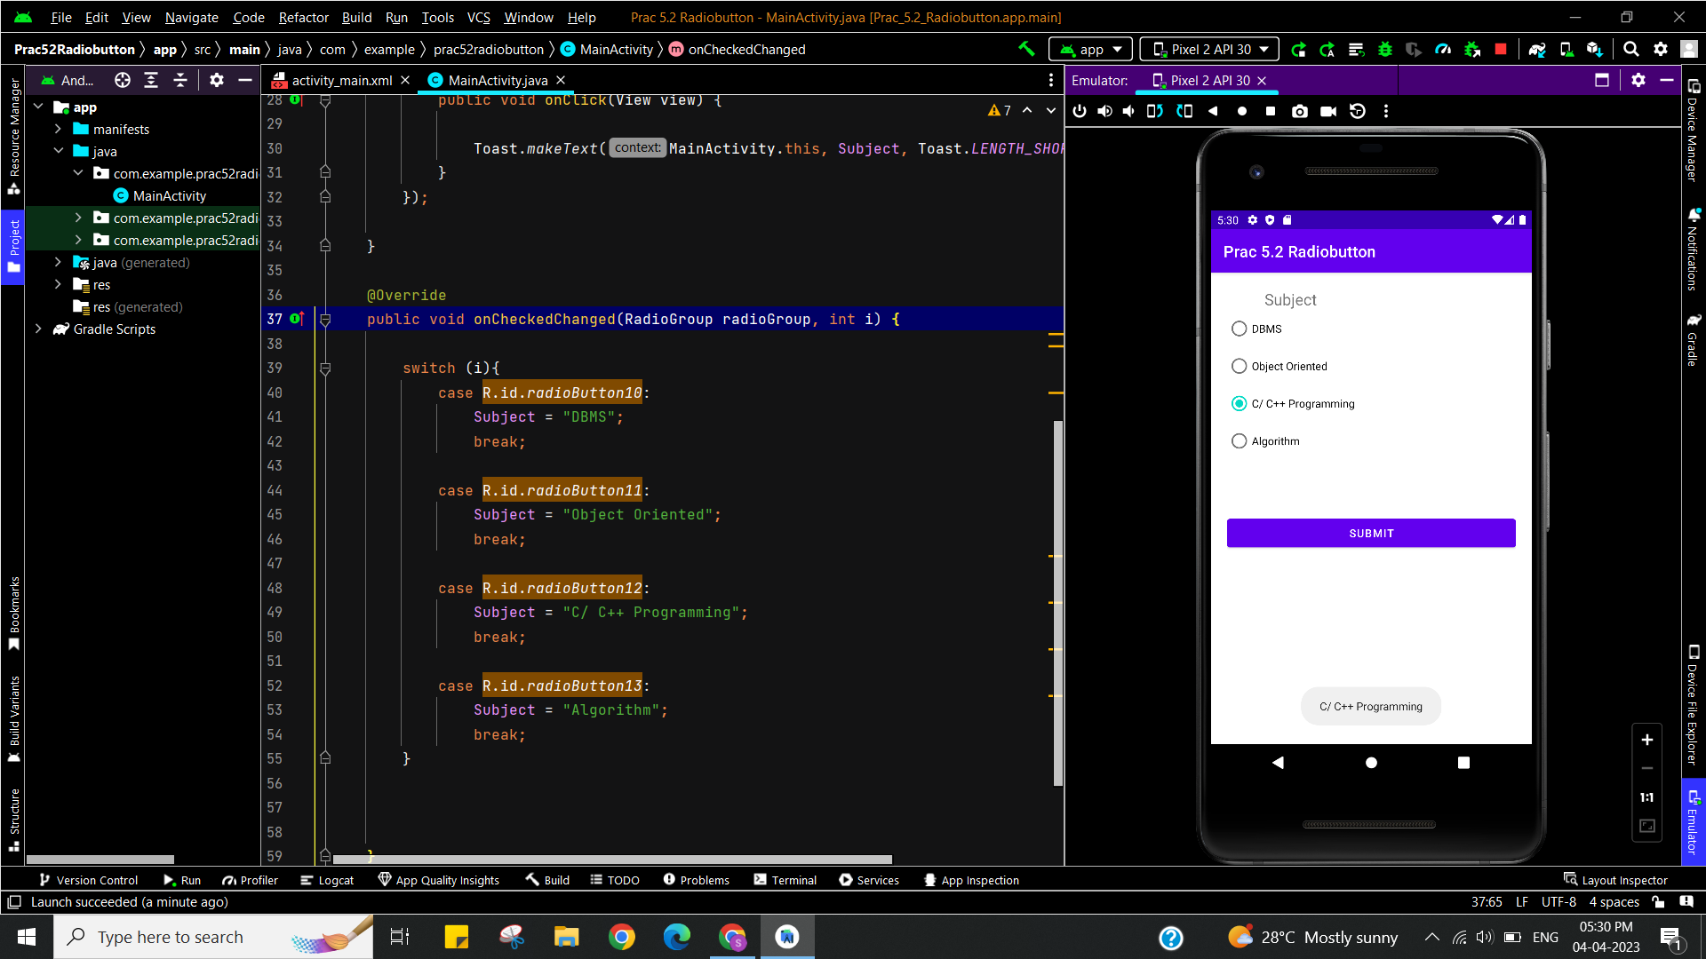

**Learning outcomes (What I have learnt):**

* To design an android application which uses RadioButtons in android studio.
* Learnt about running application on android studio.

**Evaluation Grid (To be created as per the SOP and Assessment guidelines by the faculty):**

|  |  |  |  |
| --- | --- | --- | --- |
| Sr. No. | Parameters | Marks Obtained | Maximum Marks |